Ayush Goyal
190905522 CSE D Roll 62

Operating Systems Lab 5: IPC-1: PIPE, FIFO

1. Write a producer and consumer program in C using the FIFO queue. The producer should write a set of 4 integers into the FIFO queue and the consumer should display the 4 integers.

Code:

Producer code: “l5q1prod.c”

#include<stdio.h>
#include<unistd.h>
#include<stdlib.h>
#include<sys/types.h>
#include<limits.h>
#include<fcntl.h>
#include<sys/msg.h>
#include<sys/stat.h>
#include<string.h>

#define FIFO_NAME "my_queue"
#define BUFFER_SIZE 1000

int main(int argc, char *argv[]){
int pipe_fd, res, open_mode = O_WRONLY, n = 0;
char buffer[BUFFER_SIZE+1];
if(access(FIFO_NAME, F_OK) == -1){
res = mkfifo(FIFO_NAME, 0777);
if(res != 0){
fprintf(stderr, "Could not create file %s\n", FIFO_NAME);
exit(EXIT_FAILURE);
}
}
printf("Process %d opening FIFO O_WRONLY\n", getpid());
pipe_fd = open(FIFO_NAME, open_mode);
if(pipe_fd != -1){
printf("Enter 4 numbers: \n");
while(n<4){
printf("%d : ", n+1);
scanf("%s", buffer);
res = write(pipe_fd, buffer, BUFFER_SIZE);
if(res == -1){
fprintf(stderr, "Write error on PIPE\n");
exit(EXIT_FAILURE);
}
n++;
}
close(pipe_fd);
}
else{
exit(EXIT_FAILURE);
}
printf("Process %d finished\n", getpid());
exit(EXIT_SUCCESS);
return 0;
}

Consumer code: “l5q1con.c”

#include<stdio.h>
#include<unistd.h>
#include<stdlib.h>
#include<sys/types.h>
#include<limits.h>
#include<fcntl.h>
#include<sys/msg.h>
#include<sys/stat.h>
#include<string.h>

#define FIFO_NAME "my_queue"
#define BUFFER_SIZE 1000

int main(int argc, char *argv[]){
int pipe_fd, res, open_mode = O_RDONLY, n = 0;
char buffer[BUFFER_SIZE+1];
memset(buffer, '\0', sizeof(buffer));
printf("Process %d opening FIFO O_RDONLY\n", getpid());
pipe_fd = open(FIFO_NAME, open_mode);
int bytes_read = 0;
if(pipe_fd != -1){
do{
printf("%d : ", n+1);
res = read(pipe_fd, buffer, BUFFER_SIZE);
printf("%s\n", buffer);
bytes_read += BUFFER_SIZE;
n++;
}while(n<4);
close(pipe_fd);
}
else{
exit(EXIT_FAILURE);
}
printf("Process %d finished, %d bytes read.\n", getpid(), bytes_read);
exit(EXIT_SUCCESS);
return 0;
}

Output:

We first compile and run the producer code and then the consumer code. After which we get the option to enter the 4 numbers in the producer window required which are succesfully displayed in the consumer window as shown in the output below.

Producer terminal:

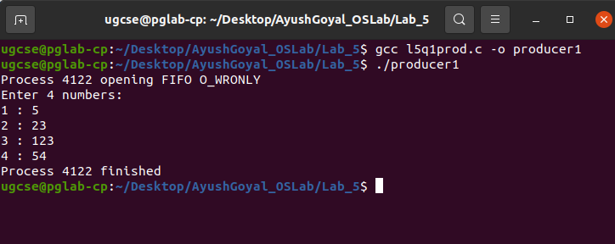

Consumer terminal:

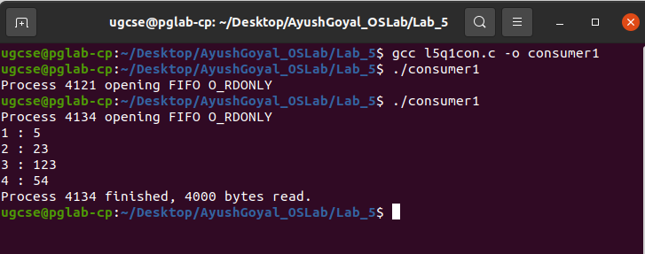

2. Demonstrate creation, writing to, and reading from a pipe.

Code:

#include<stdio.h>
#include<unistd.h>
#include<stdlib.h>
#include<sys/types.h>
#include<sys/ipc.h>
#include<sys/msg.h>
#include<string.h>

int main(int argc, char const *argv[]){
int n, fd[2];
char buf[1025], *data = "Sample Data for Ayush Goyal's 5th OS Lab";
pipe(fd);
write(fd[1], data, strlen(data));
n = read(fd[0], buf, 1024);
if(n >= 0){
buf[n] = 0;
printf("Read %d bytes from the pipe\n\"%s\"\n", n, buf);
}
else
perror("Read");
exit(0);
}

Output:

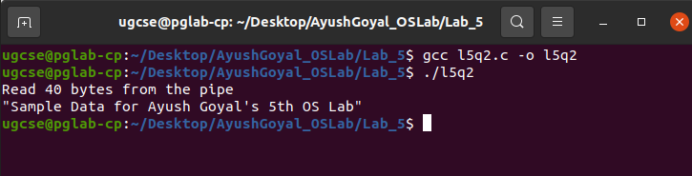

3. Write a C program to implement one side of FIFO.

Code:

First Program: “l5q3p1.c”

#include<stdio.h>
#include<unistd.h>
#include<stdlib.h>
#include<sys/types.h>
#include<limits.h>
#include<fcntl.h>
#include<sys/msg.h>
#include<sys/stat.h>
#include<string.h>

#define FIFO_NAME "my_queue"
#define BUFFER_SIZE 10000

int main(int argc, char const *argv[]){
int pipe_fd, res, open_mode1 = O_WRONLY, open_mode2 = O_RDONLY, n = 0;
char buffer[BUFFER_SIZE+1];
if(access(FIFO_NAME, F_OK) == -1){
res = mkfifo(FIFO_NAME, 0777);
if(res != 0){
fprintf(stderr, "Could not create files%s\n", FIFO_NAME);
exit(EXIT_FAILURE);
}
}

printf("Creating a program to communicate with another program through FIFO:\n");
printf("Currently in Program 1 and starting communication with Program 2...\n");
while(1){
pipe_fd = open(FIFO_NAME, open_mode2);

printf("\nText from the Program 2: ");
res = read(pipe_fd, buffer, BUFFER_SIZE);
if(strstr(buffer, "exit") != NULL)
break;
printf("%s\n", buffer);
close(pipe_fd);

pipe_fd = open(FIFO_NAME, open_mode1);

printf("\nEnter the text to send to Program 2: ");
fgets(buffer, BUFFER_SIZE, stdin);
res = write(pipe_fd, buffer, BUFFER_SIZE);

close(pipe_fd);
}
close(pipe_fd);
printf("Process %d finished.\n", getpid());
exit(EXIT_SUCCESS);
}

Second Program : “l5q3p2.c”

#include<stdio.h>
#include<unistd.h>
#include<stdlib.h>
#include<sys/types.h>
#include<limits.h>
#include<fcntl.h>
#include<sys/msg.h>
#include<sys/stat.h>
#include<string.h>

#define FIFO_NAME "my_queue"
#define BUFFER_SIZE 10000

int main(int argc, char const *argv[]){
int pipe_fd, res, open_mode1 = O_WRONLY, open_mode2 = O_RDONLY, n = 0;
char buffer[BUFFER_SIZE+1];
if(access(FIFO_NAME, F_OK) == -1){
res = mkfifo(FIFO_NAME, 0777);
if(res != 0){
fprintf(stderr, "Could not create files%s\n", FIFO_NAME);
exit(EXIT_FAILURE);
}
}

printf("Currently in Program 2 and starting communication with Program 1...\n");
while(1){
pipe_fd = open(FIFO_NAME, open_mode1);

printf("\nEnter the text to send to Program 1: ");
fgets(buffer, BUFFER_SIZE, stdin);
res = write(pipe_fd, buffer, BUFFER_SIZE);

close(pipe_fd);

pipe_fd = open(FIFO_NAME, open_mode2);

printf("\nText from the Program 1: ");
res = read(pipe_fd, buffer, BUFFER_SIZE);
if(strstr(buffer, "exit") != NULL)
break;
printf("%s\n", buffer);

close(pipe_fd);
}
close(pipe_fd);
printf("Process %d finished.\n", getpid());
exit(EXIT_SUCCESS);
}

Output:

I have compiled and executed Program 1 and then compiled and executed Program 2 concurrently. We can see in the output below that the messages are being inter communicated between both the terminals.

Terminal for Program 1:

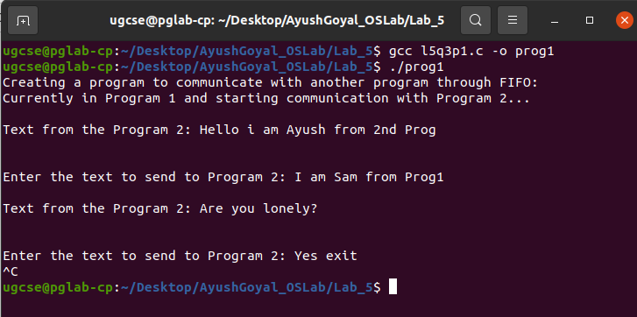

Terminal for Program 2:

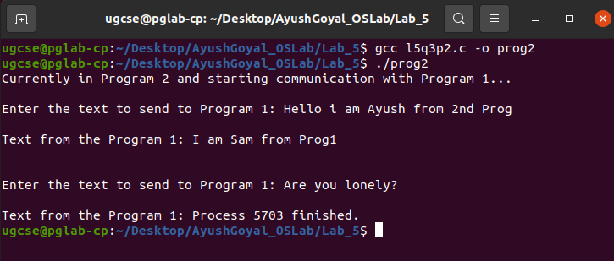

4. Write a C program reading and writing binary files in C.

Code:

#include<stdio.h>
#include<stdlib.h>

int main(){
FILE *fout;
int num = 0;
fout = fopen("my_binary_file.bin", "wb+");

printf("Enter any 4 numbers: \n");
for(int i=0;i<4;i++){
scanf("%d", &num);
fwrite(&num, sizeof(int), 1, fout);
}

printf("Writing complete!\n");
fclose(fout);

printf("Now, reading the binary file...\n");

fout = fopen("my_binary_file.bin", "rb");

for(int i=0;i<4;i++){
fread(&num, sizeof(int), 1, fout);
printf("%d\n", num);
}
fclose(fout);

return 0;
}

Output:

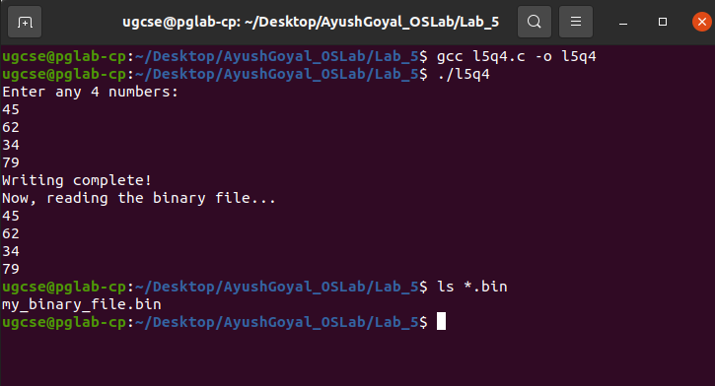

THE END

